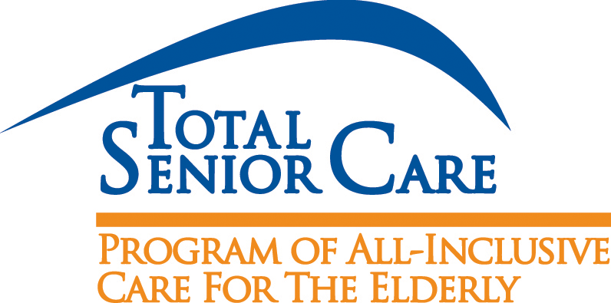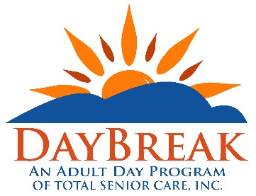
Referral for Services
**Anything in bold and italics is required information.
Participant Name:

Participant Date of Birth:

Participant Address:

County of Residence:

Participant Phone Number:

Does the Participant Have Medicare and/or Medicaid (Check Box): | ☐Medicare ☐Medicaid
Caregiver Name (if applicable):

Caregiver Phone Number:

Interested in (please check one): ☐PACE or ☐DayBreak
Whom should Total Senior Care Intake Staff contact? (please check one):☐Participant or☐Caregiver
Is the Participant and/or Caregiver aware of this referral? ☐ Yes ☐ No
Is the Participant and/or Caregiver agreeable to Total Senior Care calling them? ☐ Yes ☐ No

Please fax this form to Total Senior Care at (716) 379-8543, attention: Intake Staff
Referral form may also be submitted by mail: 519 N. Union Street Olean, NY 14760
Referral Source/Name:
Referral Source/Phone Number:
Thank you for referring to Total Senior Care!

